Wednesday 1 July - Reopened the Innovation Centre, Bio Centre, IT Centre and Enterprise House
Wednesday 8 July – Reopened The Catalyst
York Science Park are delighted to announce we reopened our buildings from the above dates. We have put the following measures in place to get the buildings Covid-19 safe. We need your cooperation to make these work, so please adhere to the guidelines and we will review these regularly in line with government restrictions.
If something is not working or gives you cause for concern, please let us know so we can find a better solution.
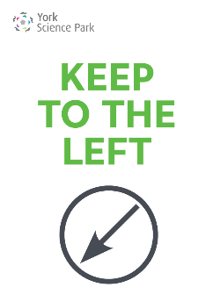
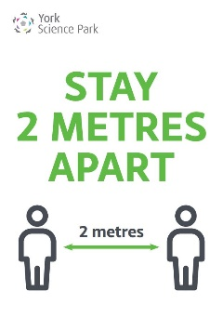
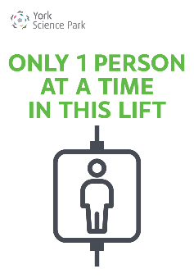
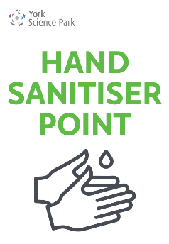
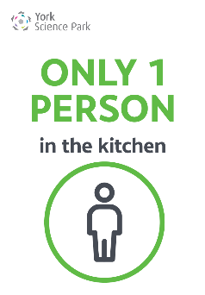
Post Arrangements
Post/Parcels
Please ensure that your name and company name are clearly stated on all on letters and parcels that are delivered to the Science Park. Missing details may result in letters or parcels being returned to sender.
Business Address
If you have an additional business address please ensure we have the details so letters and parcels are forwarded to the correct recipient.
Post Deliveries and Collections
We currently have just one delivery and collection a day to the Innovation Centre early afternoon. A member of our team then distributes the post to the relevant building and pigeonholes, when we also pick up any outgoing mail which will then be collected the following day. If you have any urgent outgoing mail you may be advised to use the Royal Mail postbox on Innovation Way.
Parcels/Couriers
Please organise your own parcel deliveries and collections with the courier directly. Deliveries can be directed to the University Mailroom, subject to approval from the Mailroom team, please contact them on 01904 322049.
- Where possible, please restrict all non-business deliveries.
- Do not place any parcels for collection on the reception desks.

Face Masks/Coverings
In line with the Government's guidance on the use of face coverings in public spaces where social distancing is not always possible, York Science Park are recommending these are adopted when moving through communal areas, particularly in corridors and stairwells. There are some circumstances, for health, age or equality reasons whereby people are not expected to wear face coverings and we ask that residents are mindful and respectful of such circumstances.
Switchboard
Please note we are operating a limited switchboard cover remotely between 09.00 - 16.00 Monday to Friday. We are unable to transfer calls to you, so messages will be taken and passed on. Please ask clients and visitors to contact you directly.
Risk Assessments
Thank you to those who have already sent us a copy of your risk assessment, we will need these before you return to site. Please find our Risk Assessment for your information here.
Car Parking
Please show consideration when using the Science Park car parks and if possible, leave a space between you and the next car. Once the car parks are busier and this isn't possible, then please allow others to park and move away from their vehicles before getting out of your own car.
Parking Permits
We appreciate some residents have changed cars during the last few months, thank you to those who have applied for your new permit on the residents portal. We will be issuing these new permits as quickly as we can and have informed the parking wardens of this situation.
Meeting Rooms
We are keeping the meeting rooms closed for now but will review this as soon as we are confident the reopening of the main buildings is running smoothly and everyone is adhering to the guidelines.
Park Central Cafe
Park Central Cafe is open for takeaway service between 09.00 - 14.00. They are operating a card/contactless payment system, so no cash please. There is a one way system through the servery using the main entrance in and the rear door onto the patio to exit. To support the NHS Test and Track system they are collecting customer names and contact numbers, via a QR code so remember to bring your phone, which will be kept for 21 days only.
Milk Deliveries
Please contact Mike Rennison directly for any milk orders: mike.rennison@yahoo.co.uk
Security
External Doors
All external doors are to be kept locked, access is by fob/key for residents and by arrangement only for others. It is essential that you lock the door behind you to prevent unauthorised access.
Alarms and In/Out Boards
As we anticipate residents may be working different shift patterns it is essential that our out of hours procedures are followed, particularly in regard to setting alarms and using the in/out boards. If you need reminding of the procedure or your alarm code please contact facilities@yorksciencepark.co.uk.
Hand Sanitiser Stations
We have installed hand sanitiser stations in each reception and entrance, please use these as you enter and exit the building.
Use of Communal Areas - Toilets and Kitchens
We are operating a one in/one out systems for the toilets and kitchens. Please remember to turn the toilet sign back to vacant upon departure.
Kitchens
Prior to the handling of communal items in the kitchen, such as kettles and microwaves, please wash your hands for at least 20 seconds.
It is highly recommended that communal cutlery and mugs should not be used, and personal ones taken home to be washed and not left in communal areas.
Hand Driers
A few residents have asked about the use of hand driers, the Government guidelines state electric hand driers are fine to use.
Showers
The showers are cleaned as part of our normal cleaning rota. Should you choose to use the shower please ensure they are rinsed down and clear of personal items after use.
Lifts
Just one person at a time in the lifts.
Cleaning
Our normal cleaning rota between 17.00 - 19.00 Monday to Friday has resumed but with an additional shift at 12.00 noon concentrating on toilets, kitchens and main touch points such as doors and banisters. If you wish to arrange and pay for a deep clean of your office, please email facilities@yorksciencepark.co.uk
Hygiene Screens
We have installed perspex hygiene screens on our reception desks but for now our reception staff will not be returning to work. Some residents have already arranged for desk screens to be installed in their offices, if you are interested in getting a quote for this please let us know.
Ventilation/Air Handling in the Buildings
We have had many questions from residents regarding air conditioning and air handling and what systems our buildings use. We actually have both types of system on site, and which building you work in, will depend on what type of system is used for your offices.
The Bio Centre, IT Centre and The Catalyst are all heated and cooled using a main air handling unit, that then feeds individual fan coil units within offices.
Our air handling units suck in fresh air from outside at roof level. The air then travels through a series of filters to ensure it is clean, before being pushed through the building ductwork and to the individual fan coil units. This air then passes over a coil within the fan coil unit, which creates tempered air. The coil is heated or cooled using hot or chilled water, depending on whether the room requires cooling or heating.
In each office there are supply grills and extract grills. As the supply grills allow the clean tempered air in, the extract grills sucks the old air out. The old air is then released externally. These systems don’t recirculate old air around the building.
The Innovation Centre, Enterprise House, and Quantum House are all much simpler buildings in terms of technology. They have a normal boiler fed heating system and the windows open for natural ventilation.
These buildings also have quite a few individual air conditioning systems. The guidance around using air conditioning during the pandemic is mixed. Our advice would be to only use your air conditioning if absolutely necessary, for the time being. It is much better to increase natural ventilation within your offices, by opening windows and doors (not fire doors) where possible.
All our air handling and air conditioning systems have been serviced and cleaned during the lockdown. All air handling units have received new filters and the filters within air conditioning units have also been cleaned.

Visitors
We all need to minimise the number of unnecessary visits:
- Encourage virtual meetings
- Where site visits are unavoidable, guidance on social distancing and hygiene should be explained to visitors on or before arrival
- Limit the number of visitors at any one time
- Limit visitor times to a specific time window
Respecting Others' Space
Please show consideration for other people's space at all times, this includes:
- Entering and exiting your car
- Entering and exiting the buildings
- Passing others in corridors
- Use of the kitchens and toilets
NHS Test and Trace
If anyone develops symptoms, they should request a free test immediately. They will be asked by the NHS Test and Trace service to provide details of anyone who they have been in close recent contact with. This is not automatically all their co-workers, but anyone who is defined as a close contact:
- Has had face to face contact within one metre including:
    - Being coughed on
    - Having skin to skin physical contact
    - Contact within one metre for one minute
- Has been within 2 metres of someone who has tested positive for Covid-19 for more than 15 minutes
- Has travelled in a vehicle with them
Close contacts at this stage do not need to self-isolate, unless requested to do so by NHS Test and Trace or a public health professional should the person with the symptoms test positive. When Test and Trace advises contacts to self-isolate, the service does not tell them the identity of the person who has tested positive.
You should help your employees self-isolate for 14 days if they:
- have coronavirus symptoms and are waiting for a test result
- have tested positive for coronavirus
- are a member of the same household as someone who has symptoms or has tested positive for coronavirus
- have been in close recent contact with someone who has tested positive and received a notification to self-isolate from NHS Test and Trace
You should not share the identity of a worker who has tested positive with other workers.

