Wednesday 1 July - Reopening the Innovation Centre, Bio Centre, IT Centre and Enterprise House
Wednesday 8 July – Reopening The Catalyst
York Science Park are delighted to announce we are reopening our buildings from the above dates. We have put the following measures in place to get the buildings Covid-19 safe. We need your cooperation to make these work, so please adhere to the guidelines and we will review these regularly in line with government restrictions.
If something is not working or gives you cause for concern, please let us know so we can find a better solution.
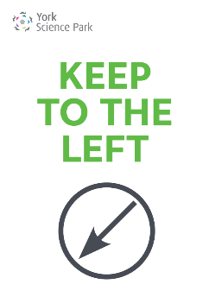
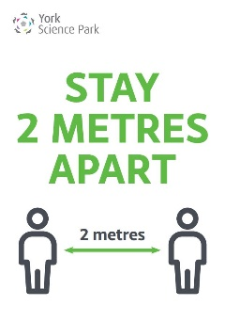
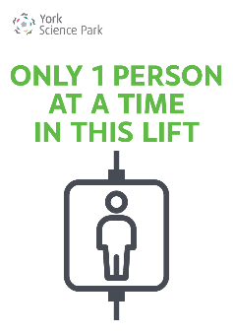
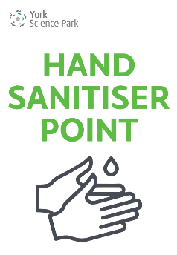
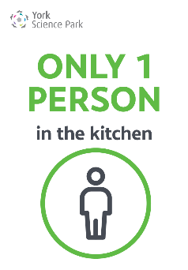
Post Arrangements
On 1 July all parcels and mail currently stored in the University's Mailroom will be delivered to the Science Park and placed in your pigeonholes for collection. After this date our Royal Mail collection and deliveries will be just once a day to each centre.
Parcels/Couriers
Please organise your own parcel deliveries and collections with the courier directly. Deliveries can be directed to the University Mailroom, subject to approval from the Mailroom team, please contact them on 01904 322049.
- Where possible, please restrict all non-business deliveries.
- Do not place any parcels for collection on the reception desks.
Switchboard
Please note we will be operating a limited switchboard cover remotely between 09.00 - 16.00 Monday to Friday. Please ask clients and visitors to contact you directly.
Risk Assessments
Thank you to those who have already sent us a copy of your risk assessment, we will need these before you return to site. Please find our Risk Assessment for your information here.

Car Parking
Please show consideration when using the Science Park car parks and if possible, leave a space between you and the next car. Once the car parks are busier and this isn't possible, then please allow others to park and move away from their vehicles before getting out of your own car.
Parking Permits
We appreciate some residents have changed cars during the last few months, thank you to those who have applied for your new permit on the residents portal. We will be issuing these new permits as quickly as we can and have informed the parking wardens of this situation.
Meeting Rooms
Initially we are keeping the meeting rooms closed but will review this as soon as we are confident the reopening of the main buildings is running smoothly and everyone is adhering to the guidelines.
Park Central Cafe
From 1 July Park Central Cafe will reopen for takeaway service only between 09.00 - 14.00. They will operate a card/contactless payment system, so no cash please. There will be a one way system through the servery using the main entrance in and the rear door onto the patio to exit. To support the NHS Test and Track system they will be collecting customer names and contact numbers, which will be kept for 21 days only.
Milk Deliveries
Please contact Mike Rennison directly for any milk orders: mike.rennison@yahoo.co.uk
Main Doors
All main doors will be kept locked, access is by fob/key for residents and by arrangement only for others. Please ensure you lock the door behind you.
Alarms and In/Out Boards
As we anticipate residents may be working different shift patterns it is essential that our out of hours procedures are followed, particularly in regard to setting alarms and using the in/out boards. If you need reminding of the procedure or your alarm code please contact facilities@yorksciencepark.co.uk.
Hand Sanitiser Stations
We are installing hand sanitiser stations in each reception and entrance, please use these as you enter and exit the building.
Use of Communal Areas - Toilet and Kitchens
We will be operating a one in/one out systems for the toilets and kitchens.
Hand Driers
A few residents have asked about the use of hand driers, the Government guidelines state electric hand driers are fine to use.
Showers
For now, these will remain closed but we will review this if there is a demand.

Lifts
Just one person at a time in the lifts.
Cleaning
Our normal cleaning rota will resume on 1 July between 17.00 - 19.00 Monday to Friday with an additional shift at 12.00 noon concentrating on toilets, kitchens and main touch points such as doors and banisters.
Hygiene Screens
We have installed perspex hygiene screens on our reception desks but for now our reception staff will not be returning to work. Some residents have already arranged for desk screens to be installed in their offices, if you are interested in getting a quote for this please let us know.
Ventilation/Air Handling in the Buildings
We have had many questions from residents regarding air conditioning and air handling and what systems our buildings use. We actually have both types of system on site, and which building you work in, will depend on what type of system is used for your offices.
The Bio Centre, IT Centre and The Catalyst are all heated and cooled using a main air handling unit, that then feeds individual fan coil units within offices.
Our air handling units suck in fresh air from outside at roof level. The air then travels through a series of filters to ensure it is clean, before being pushed through the building ductwork and to the individual fan coil units. This air then passes over a coil within the fan coil unit, which creates tempered air. The coil is heated or cooled using hot or chilled water, depending on whether the room requires cooling or heating.
In each office there are supply grills and extract grills. As the supply grills allow the clean tempered air in, the extract grills sucks the old air out. The old air is then released externally. These systems don’t recirculate old air around the building.
The Innovation Centre, Enterprise House, and Quantum House are all much simpler buildings in terms of technology. They have a normal boiler fed heating system and the windows open for natural ventilation.
These buildings also have quite a few individual air conditioning systems. The guidance around using air conditioning during the pandemic is mixed. Our advice would be to only use your air conditioning if absolutely necessary, for the time being. It is much better to increase natural ventilation within your offices, by opening windows and doors (not fire doors) where possible.
All our air handling and air conditioning systems have been serviced and cleaned during the lockdown. All air handling units have received new filters and the filters within air conditioning units have also been cleaned.
Visitors
We all need to minimise the number of unnecessary visits:
- Encourage virtual meetings
- Where site visits are unavoidable, guidance on social distancing and hygiene should be explained to visitors on or before arrival
- Limit the number of visitors at any one time
- Limit visitor times to a specific time window
Respecting others' space
Please show consideration for other people's space at all times, this includes:
- Entering and exiting your car
- Entering and exiting the buildings
- Passing others in corridors
- Use of the kitchens and toilets

